This document evaluates behaviour for OIC message consumption for OIC specifically focused on Message Consumption for Process Automation as reported here:
https://docs.oracle.com/en/cloud/paas/application-integration/oracle-integration-oci/how-billing-message-usage-is-calculated-based-feature.html#GUID-FB792D75-C8A6-41A2-AC3D-E48AA586F142

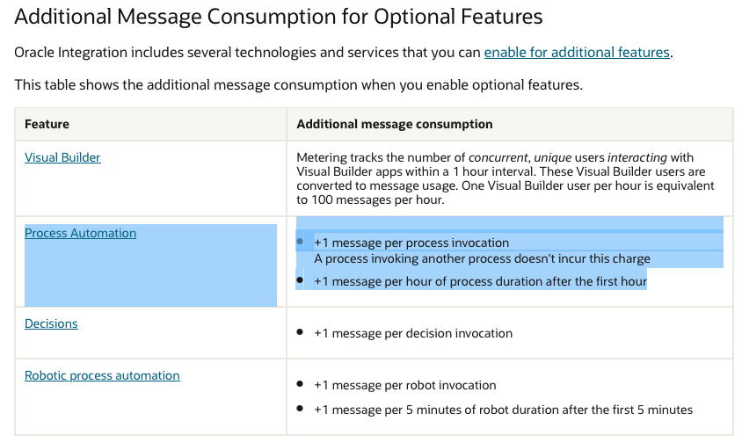

I have two active processes:
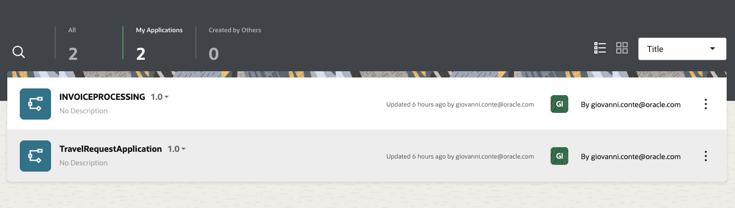

Two active process instances on Nov 17th:
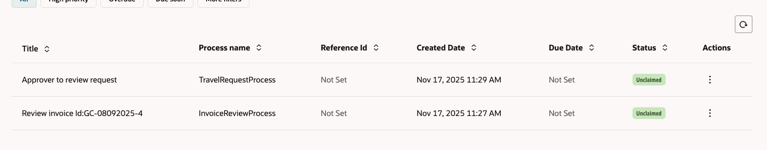

I issued10 new process instances on Nov 18th in the 9:00 – 10:00 timeframe
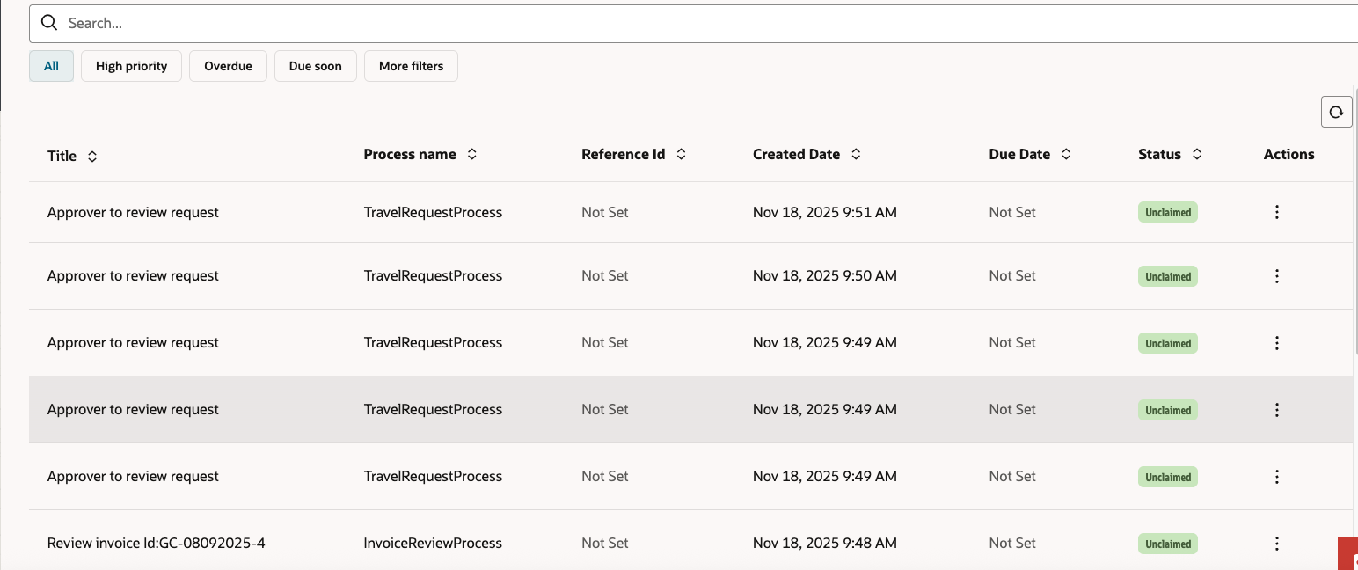

Now I have have 2 (Nov 17th) + 10 (Nov 18th) active instances.
I then completed 5 of these 10 active instances in the 9:00 – 10:00 timeframe

Before 10:00 am then we have issued 10 process invocation and we have 7 remaining active processes.

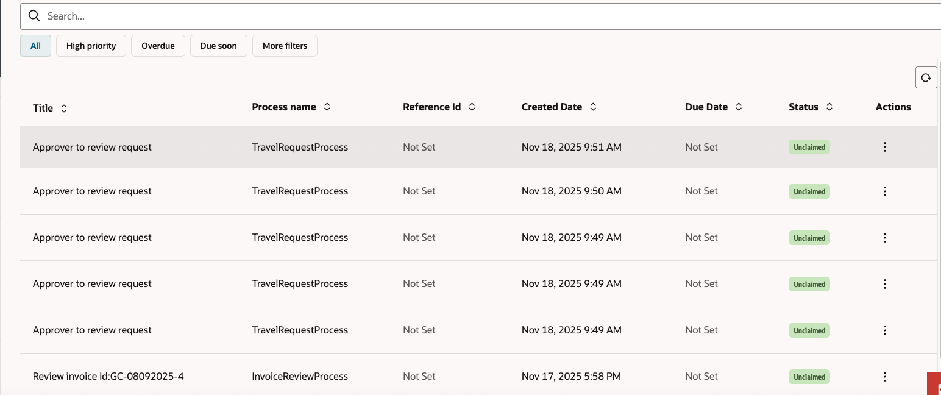

Let’s now see the “Consumed messages for Process Automation” metric (please consider that metric is reported in UTC, so with 1 h before time shift.
The metric is working exactly as expected reporting the sum of “process invocation” and “process duration after first hour”.

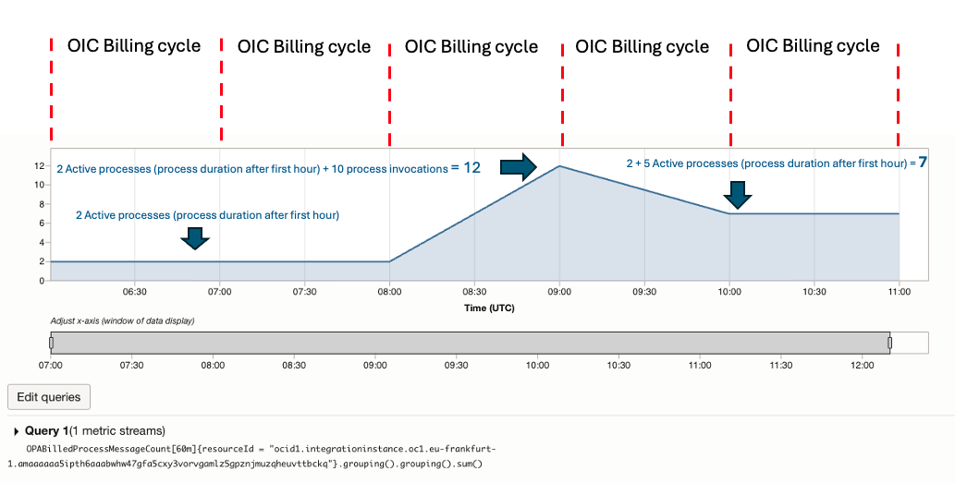

The related single specific metrics are:

- for“process invocation”
InvokedProcessCount[60m]{resourceId = "<ocid>"}.grouping().grouping().sum()

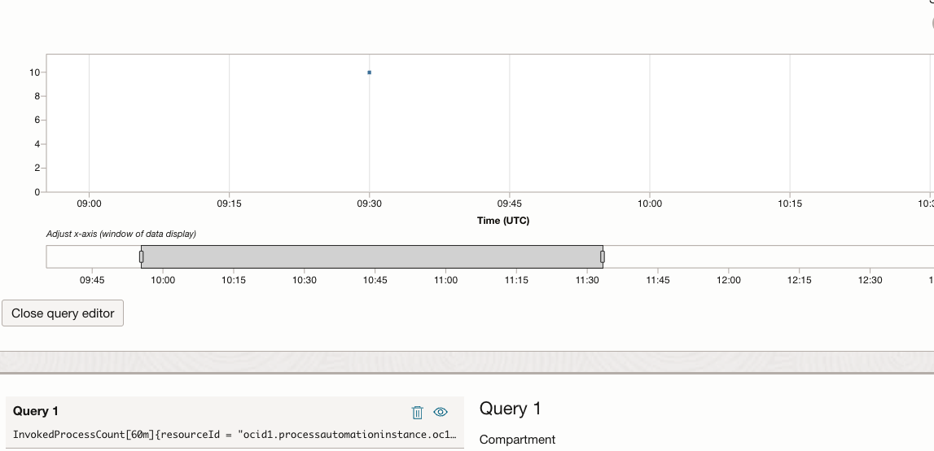

- for “process duration after first hour”
ActiveProcessCount[60m]{resourceId = "<ocid>"}.grouping().grouping().sum()

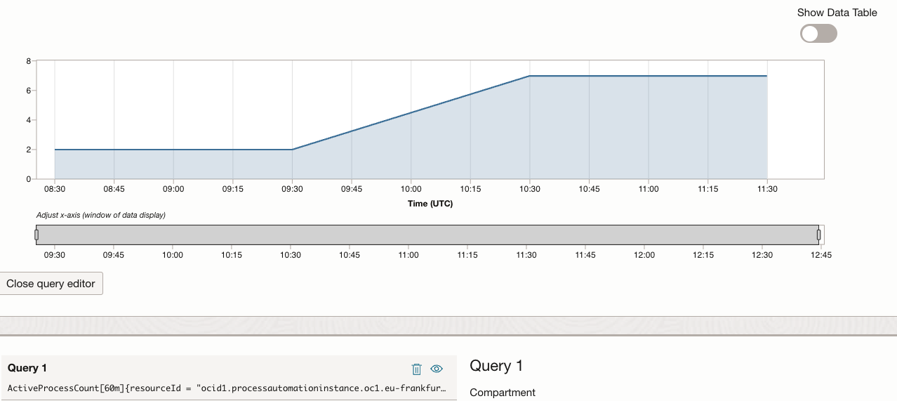

Now let’s consider a customer having an existing Oracle Process Automation Standalone who needs to know how much he will consume when processes will be running in the OPA embedded / associated with OIC.
In OPA standalone they can use following metrics:
“Number of processes invoked for OPA” which is equivalent to the above mentioned ““process invocation”
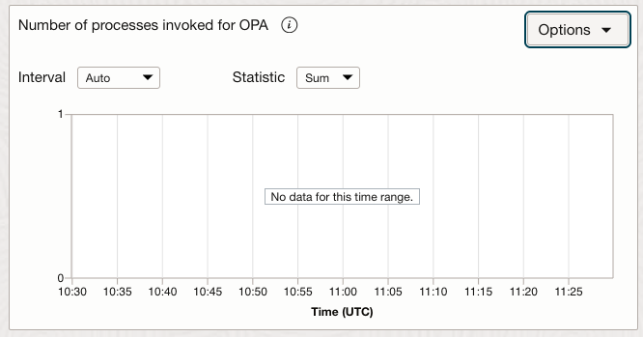

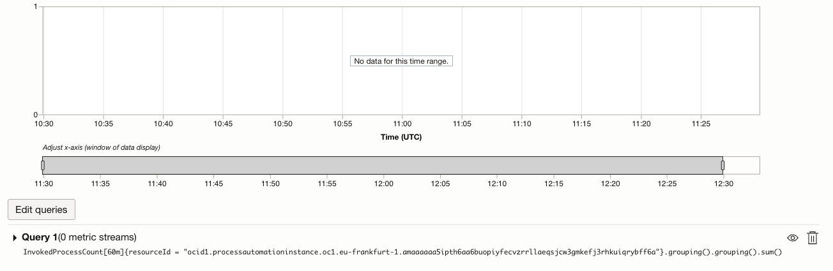

“Number of active OPA processes” which is equivalent to “process duration after first hour” if they are expected to continue to be active
